Experiment 14: Creating and Testing a Snapshot of a VM
Aim
To create a snapshot of a Virtual Machine and restore the previous version using VirtualBox.
Steps
- Start the Virtual Machine.
- Install OS and make basic configurations.
- Power off or pause the VM.
- Go to Snapshots section in VirtualBox.
- Click Take Snapshot and name it
- Make changes to the VM (software install/settings).
- Restore the snapshot by selecting it and clicking Restore.
- Start the VM again.
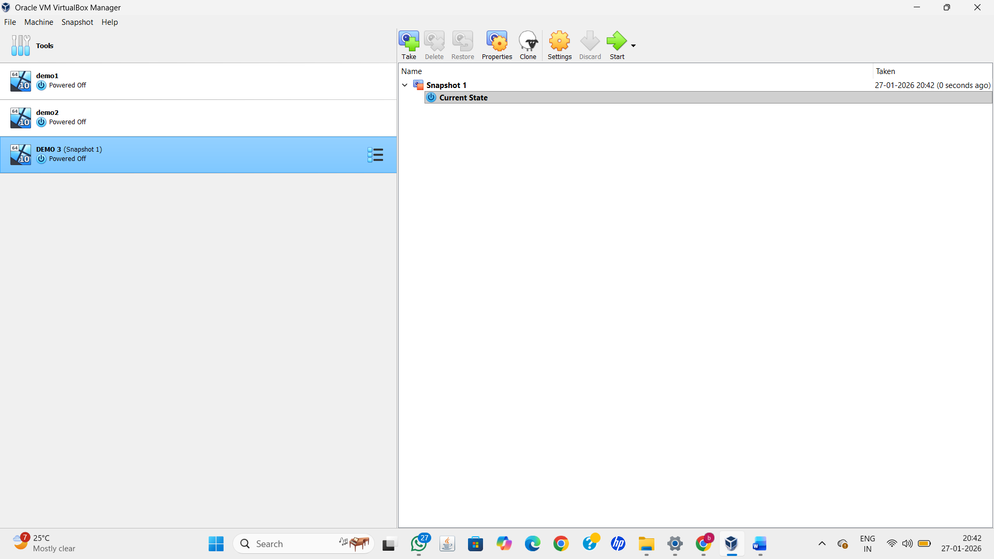
Result
Snapshot was successfully created and restored, reverting the VM to its previous state.

